ACTIVATING THE SERVICE FOR NEW LOCATION (PANCHAYAT):
STEP 1:
Login as a panchayat department admin (DA) user for particular panchayat.ex-WB000183. Assign the roles one by one by selecting the service as required.
By selecting the service to be activated then the officials of the (Gram Panchayat-Rural) to be selected which would lead to open a pop up window.
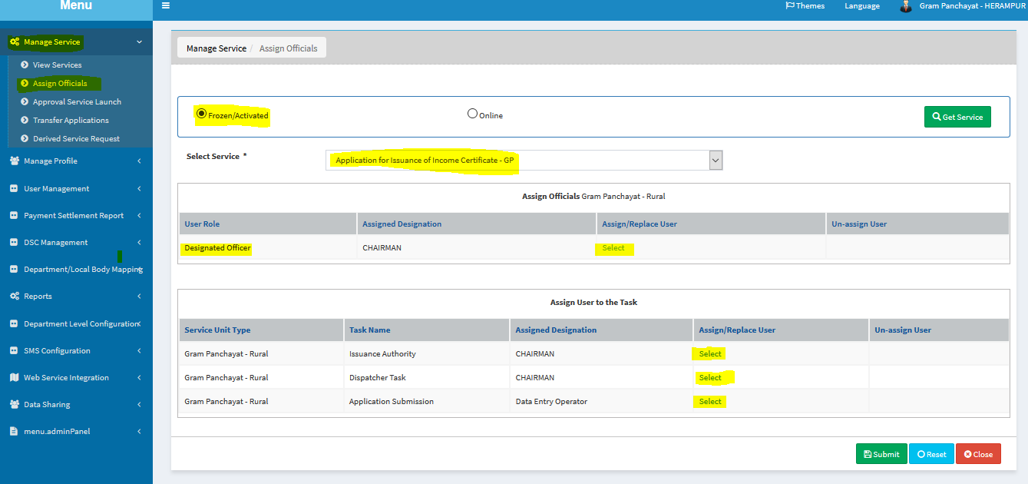

STEP 2:
Now select all the field like this.
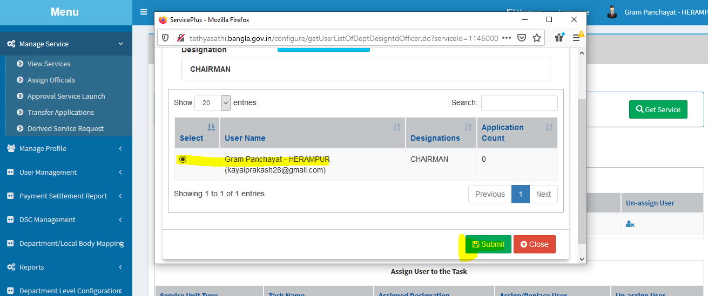

STEP 3:
Finally click submit button after selecting all the fields for the application to be activated.

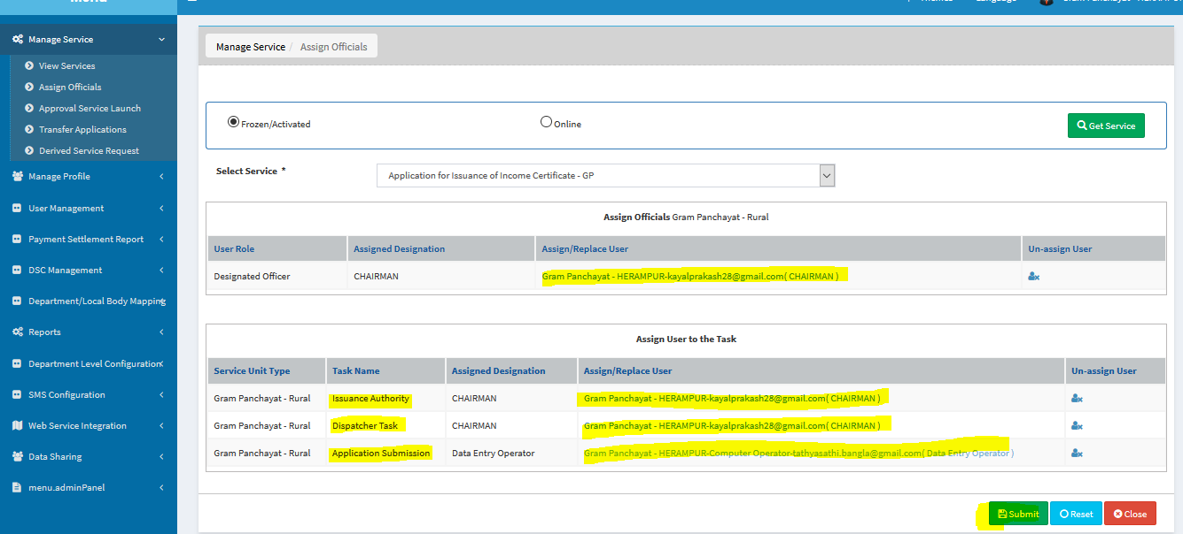

STEP 4:
After successfully submitting the application logout user and re login with panchayat department admin (DA) for particular panchayat.ex-WB000183.
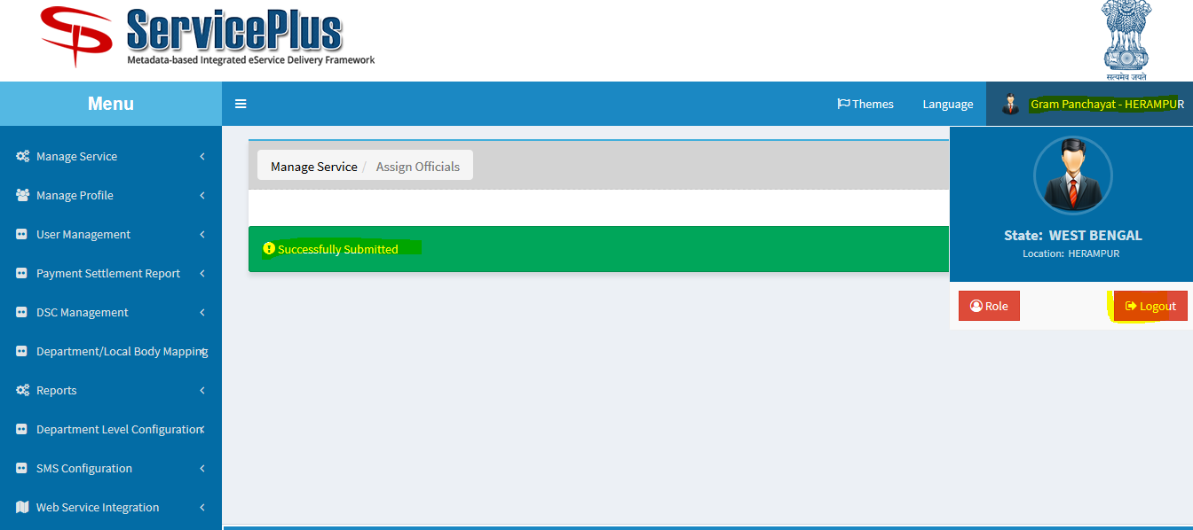

STEP 5:
After Re Login select to “Activate Service” and “modify” icon.
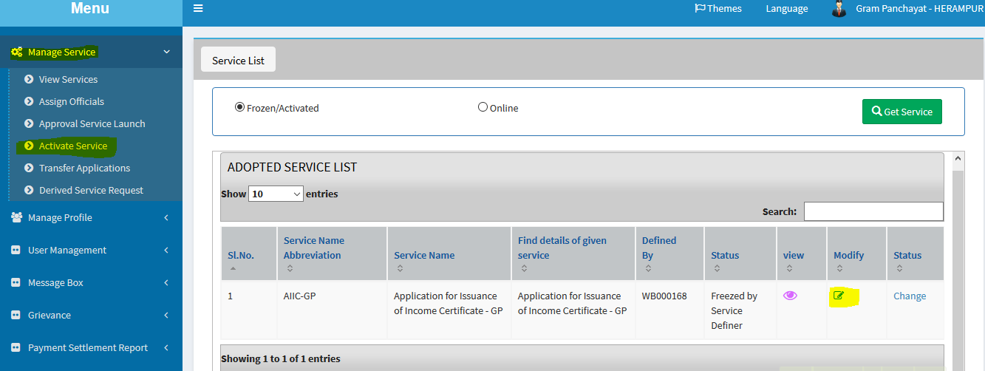
STEP 6:
Select the service unit in mode of submission tab and fill the address fields and click on ADD button
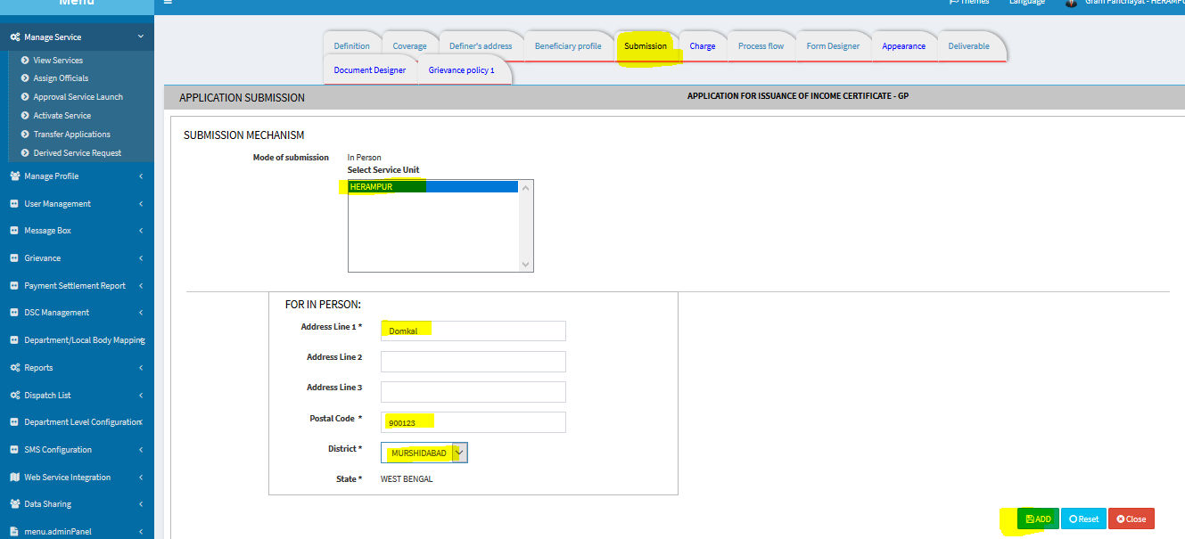
STEP 7:
And again select “Activate Service” tab and click on “Change”.
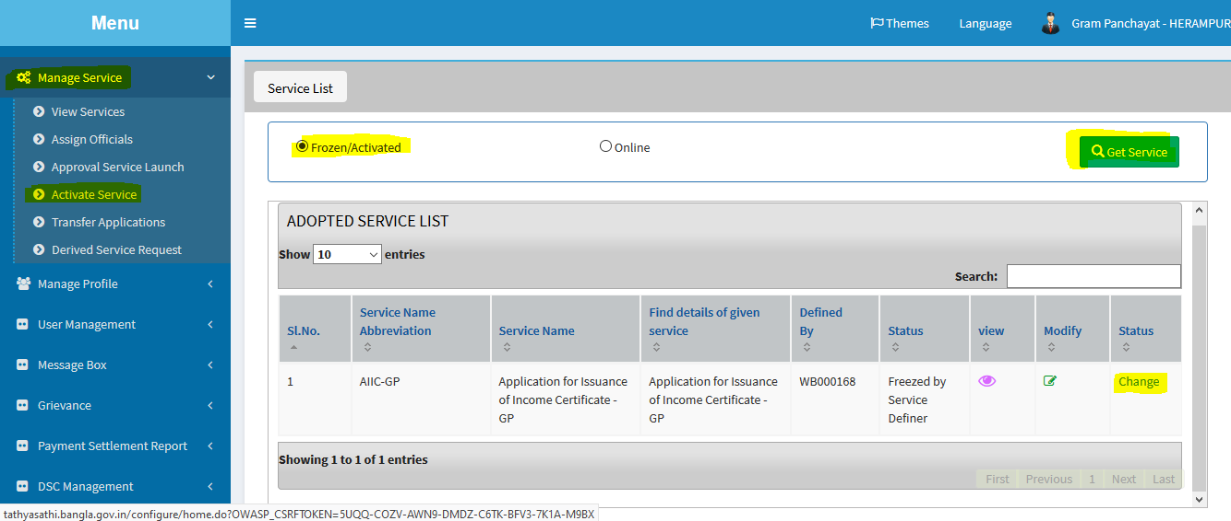
STEP 8:
And now select the appropriate dropdown value and hit the button ”GET LIST” which would list the Service unit and check the checkbox to submit.
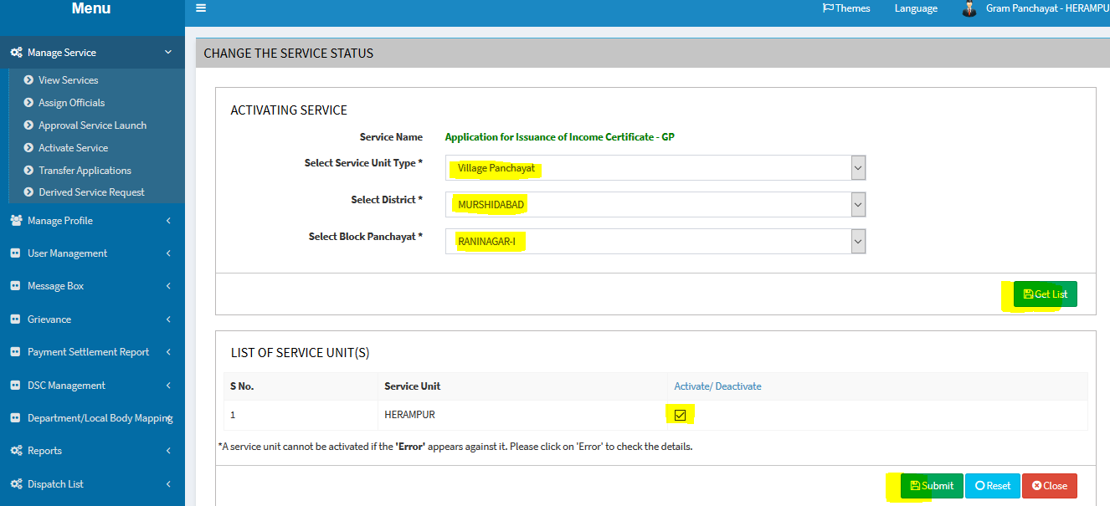
STEP 8:
Finally after submitting the button the application has been activated.

